**Team Information**

Team Name: Wildcard

Team Members: Nicole Emich, Felix Zhu, Julianne De la parra, and Mike Harris.

**Overview and Project Scope:**

Team Wildcard will be developing an application that’s similar to DePaul’s Campus Connect application, which is a web portal that allows students to perform self-service tasks related to their coursework. We will be creating a similar portal that delivers a subset of features such as adding courses, dropping courses, viewing grades/progress, and managing personal information.

GitHub location for source code: <https://github.com/mikeharris-github/SE452-WildCard>

Use case diagram:

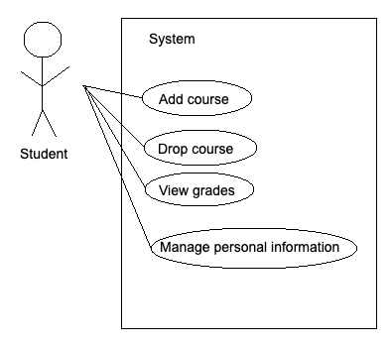

**Team Issue Resolution Agreement:**

When a conflict arises in the group, we will determine all possible options and put it to a group vote. The majority vote wins and will be the final decision. If there’s a tie, it will result in a coin flip.

If all else fails and we can still not come to an agreement or we have an issue in which we find ourselves not able to resolve, we will consult with Professor Yu.

**Communication mechanism:**

Microsoft Teams

**Meeting times:**

While meeting times may vary throughout the semester, our meeting times work best during the weeknight evenings. We will also be communicating via Microsoft Teams.

**Decisions made (editor, project scope)**

The team will be using IntelliJ for the code editor. Regarding project scope, see the overview section above.

**Screenshot of working code**

N/A for milestone 1. See skeleton code uploaded in GitHub repo: <https://github.com/mikeharris-github/SE452-WildCard>

**Presentation for Milestone 1**

[SE452 Group Meeting-20210920_222407-Meeting Recording.mp4](https://depauledu-my.sharepoint.com/:v:/g/personal/mharr111_depaul_edu/Ed8sYI5SzmRComGmybmDAAUBZZJTWEsXHgj0VnHN-MihUA?email=MHARR111%40depaul.edu)